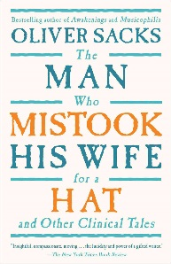
The Man who Mistook His Wife for a Hat by Oliver Sacks

Directions: When you have finished reading the chapters, please answer the following questions for any two (2) of the chapters that we read in class.

Chapter Analysis Questions:
- Introduction: Brief chapter summary. Explain the most important parts of the chapter

- What were this patient’s symptoms? (i.e. what problems was he/she experiencing?)
(If mentioned) What disorders were described? What may have caused this disorder?
Are the symptoms mental illness or cognitive dysfunction?

- What is Dr. Sacks’ diagnosis? Include the name of the disorder and a description of what it is,
in your own words. How did Dr. Sacks treat this patient’s disorder (what solution did he offer them)? If he offered a follow-up of this patient, how is he/she doing today?

- Conclusion about the chapter:
- What did you learn? Did you find this reading selection interesting? Why or why not?
- How would you treat someone with one of these dysfunctions/illnesses? Be specific

In order to receive the full credit points, you must meet the following requirements: (
- Typed, double spaced, 12 pt. Times New Roman font
- One full page, minimum, for each chapter (2 pages total)
- Title of page should be the title of the chapter you read
- Questions above answered as thoughtfully and thoroughly as possible

Chapters from The Man who Mistook His Wife for a Hat:
Choose 2 of the 4 to include:
Phantoms
Cupid’s Disease
Eyes Right
The President’s Speech

